**Exp 2** Design Christmas dual led chaser lights

**CIRCUIT DIAGRAM**

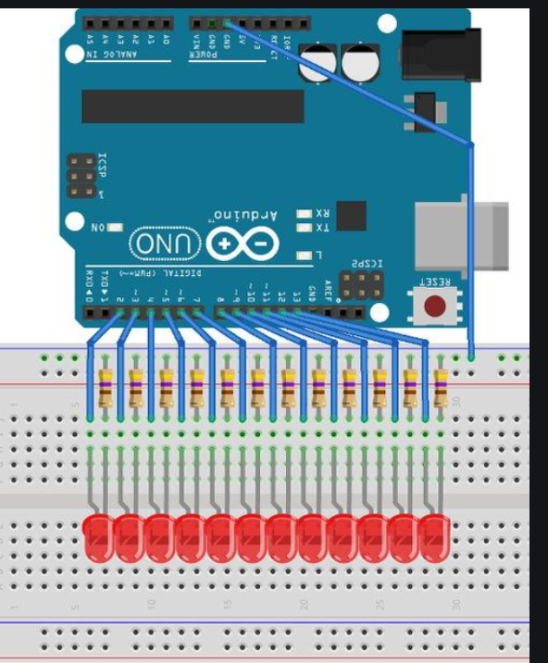

**THEORY**

**CONCEPT USED**

LED’S p side are connected to different input but they all have a same ground. Different input signal is given to different LED’s which leads to different pattern.

**LEARNING AND OBSERVATION**

Different signal given to a LED leads to show casing of different pattern.

**PROBLEM AND TROUBLESHOOTING**

While making the circuit, connection are needed to be maintained corrected. Problem which can be faced is only with the connections or problem with LED.

**PRECAUTIONS**

1. Connections must be tight and correct.
2. Coding must be right.
3. Components used must be working properly.
4. It is better to keep the circuit switched off when it is not in use.

**LEARNING OUTCOMES**

Using such system make anyone to make their own LED chaser.